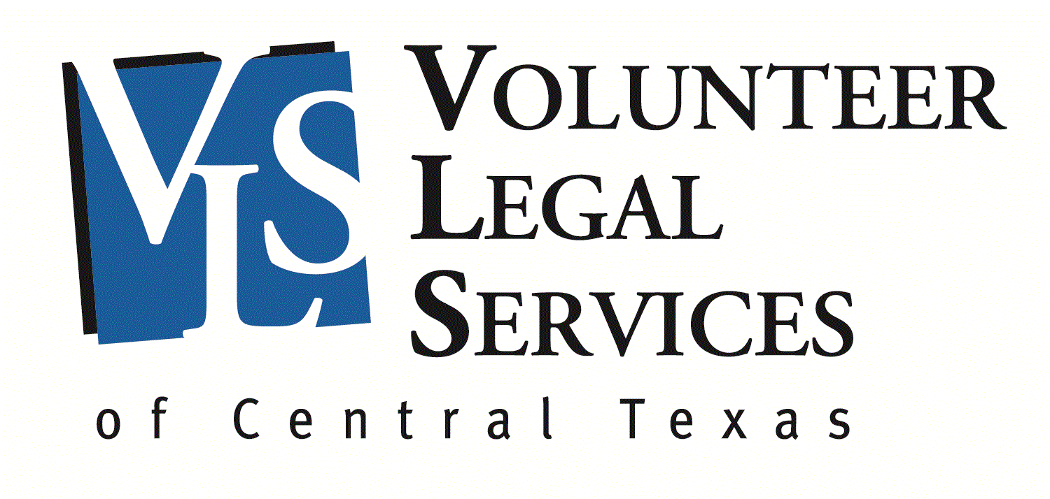
Scott Ozmun Fellowship
A Program of Volunteer Legal Services of Central Texas
2021-2022

APPLY NOW

The Scott Ozmun Fellowship provides financial support to a law student to work with local lawyers on pro bono civil cases under the supervision of Volunteer Legal Services of Central Texas (VLS) staff attorneys. Our attorney volunteers help survivors of abuse end violent relationships, connect persons with disabilities with medical and financial benefits, and keep people out of homelessness by defending against wrongful evictions and foreclosures.

This program is funded by generous gifts received by VLS in memory of Scott Ozmun, former judge of the 353rd District Court in Travis County and graduate of the University of Texas School of Law. Judge Ozmun was a strong believer in lawyers helping low-income people access justice by volunteering to take pro bono cases and mentoring students to become great lawyers.

The Fellow will work under the supervision of a VLS staff attorney. The Fellow will assist lawyers who have agreed to handle pro bono matters through VLS, with an emphasis on family law matters. The work may include intake for new clients, assisting attorneys with client interviews, drafting legal documents, pleadings, and orders, interpreting for court hearings, and helping run VLS’ bi-weekly family law legal advice clinics.

The fellowship will provide a $5,000 stipend for 250 hours during the 2021-2022 academic year or $2,500 for 125 hours during either the fall or spring semester. At this time due to the ongoing threat of the coronavirus pandemic, VLS’ office is closed and all staff are working remotely. The Fellow will also be working 100% remotely unless and until VLS determines it is safe to return to work in-person.

The Fellow may not earn academic credit for the fellowship work.

Application Information

Applicants must be entering their 2nd or 3rd year at the University of Texas School of Law in the fall of 2021, and be proficient in Spanish. The Fellow will be selected by VLS based on academic credentials and commitment to public service.

Applications will be accepted on a rolling basis until May 30, 2021 or until filled. VLS will contact applicants to schedule interviews. All interviews will be conducted remotely.

Applications must include the following:

1. A cover sheet with your name and your contact information;
2. One to two double-spaced pages describing your interest in the fellowship and your commitment to public service;
3. Resume;
4. Law school transcript;
5. A statement of your proficiency in Spanish;
6. List of three references (including address and phone), preferably including one UT Law faculty member; and
7. A statement regarding your preference for a full academic year, fall semester, or spring semester fellowship.

Application Deadline: Rolling until May 30, 2021 or until filled.

Applications and Questions should be submitted to Kate Hannaher, Staff Attorney at khannaher@vlsoct.org.

